**Okrskové kole ve vybíjené – Karolinka 2013 - hoši**

|  |  |  |  |  |  |  |
| --- | --- | --- | --- | --- | --- | --- |
| **C:\Users\josef\AppData\Local\Microsoft\Windows\Temporary Internet Files\Content.IE5\L30N5SQ5\MC900320434[1].wmf** | **ZŠ VELKÉ KARLOVICE** | **ZŠ HALENKOV** | **ZŠ KAROLINKA** | **ZŠ HOVĚZÍ** | **SKORE** | **POŘADÍ** |
| **ZŠ VELKÉ KARLOVICE** | **C:\Users\josef\AppData\Local\Microsoft\Windows\Temporary Internet Files\Content.IE5\L30N5SQ5\MC900320434[1].wmf** | **5:11** | **8:11** | **15:11** | **28:33** | **4.** |
| **ZŠ HALENKOV** | **11:5** | **C:\Users\josef\AppData\Local\Microsoft\Windows\Temporary Internet Files\Content.IE5\L30N5SQ5\MC900320434[1].wmf** | **9:15** | **11:15** | **31:35** | **3.** |
| **ZŠ KAROLINKA** | **11:8** | **15:9** | **C:\Users\josef\AppData\Local\Microsoft\Windows\Temporary Internet Files\Content.IE5\L30N5SQ5\MC900320434[1].wmf** | **7:11** | **33:28** | **2.** |
| **ZŠ HOVĚZÍ** | **11:15** | **15:11** | **11:7** | **C:\Users\josef\AppData\Local\Microsoft\Windows\Temporary Internet Files\Content.IE5\L30N5SQ5\MC900320434[1].wmf** | **37:33** | **1.** |

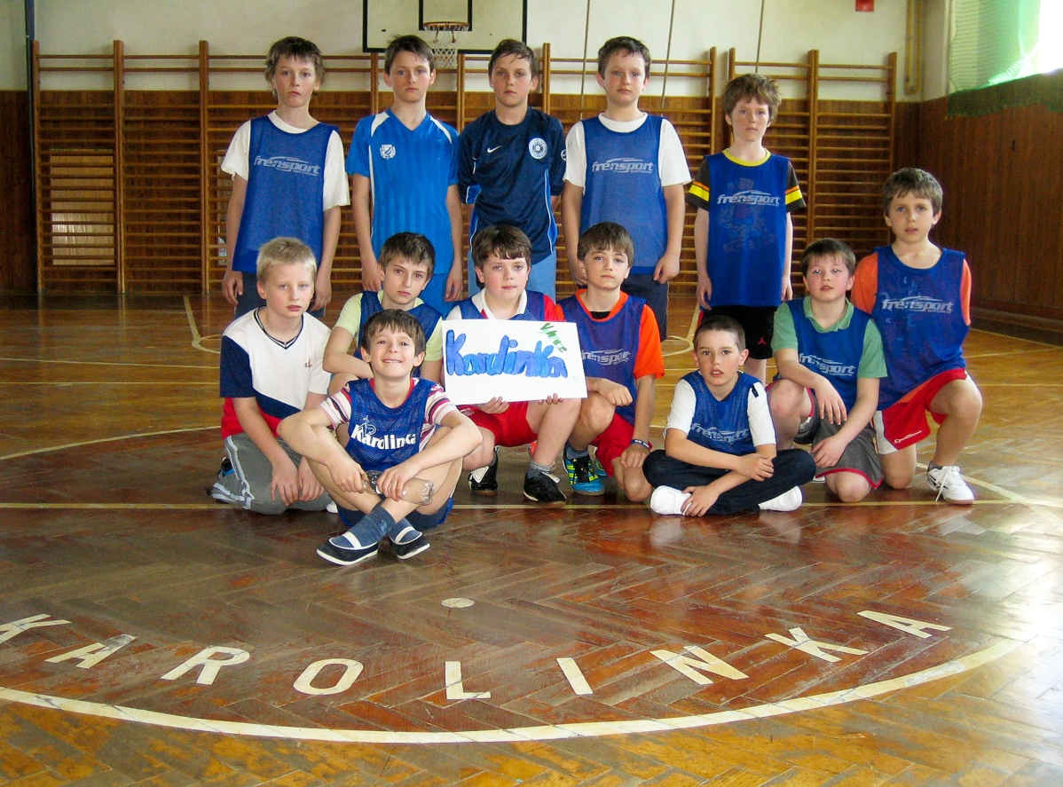

**Okrskové kole ve vybíjené – Halenkov 2013 – dívky**

|  |  |  |  |  |  |
| --- | --- | --- | --- | --- | --- |
| **C:\Users\josef\AppData\Local\Microsoft\Windows\Temporary Internet Files\Content.IE5\L30N5SQ5\MC900320434[1].wmf** | **ZŠ KAROLINKA** | **ZŠ VELKÉ KARLOVICE** | **ZŠ HALENKOV** | **SKORE** | **POŘADÍ** |
| **ZŠ KAROLINKA** | **C:\Users\josef\AppData\Local\Microsoft\Windows\Temporary Internet Files\Content.IE5\L30N5SQ5\MC900320434[1].wmf** | **7:12** | **7:8** | **14:20** | **3.** |
| **ZŠ VELKÉ KARLOVICE** | **12:7** | **C:\Users\josef\AppData\Local\Microsoft\Windows\Temporary Internet Files\Content.IE5\L30N5SQ5\MC900320434[1].wmf** | **12:5** | **24:12** | **1.** |
| **ZŠ HALENKOV** | **8:7** | **5:12** | **C:\Users\josef\AppData\Local\Microsoft\Windows\Temporary Internet Files\Content.IE5\L30N5SQ5\MC900320434[1].wmf** | **13:19** | **2.** |

