Volejbal okrsek 2013 hoši

|  |  |  |  |  |  |  |
| --- | --- | --- | --- | --- | --- | --- |
| C:\Users\skola\AppData\Local\Microsoft\Windows\Temporary Internet Files\Content.IE5\KL8A44QK\MC900398269[1].wmf | Karolinka | Nový Hrozenkov | Hovězí | body | skóre | pořadí |
| Karolinka | C:\Users\skola\AppData\Local\Microsoft\Windows\Temporary Internet Files\Content.IE5\KL8A44QK\MC900398269[1].wmf | 2:0  (25:23,25:13) | 1:1  (8:25,25:13) | 3 | 83:74 | 2. |
| Nový Hrozenkov | 0:2  (23:25,13:25) | C:\Users\skola\AppData\Local\Microsoft\Windows\Temporary Internet Files\Content.IE5\KL8A44QK\MC900398269[1].wmf | 0:2  (14:25,14:25) | 0 | 64:100 | 3. |
| Hovězí | 1:1  (25:8, 13:25) | 2:0  (25:14,25:14) | C:\Users\skola\AppData\Local\Microsoft\Windows\Temporary Internet Files\Content.IE5\KL8A44QK\MC900398269[1].wmf | 3 | 88:61 | 1. |

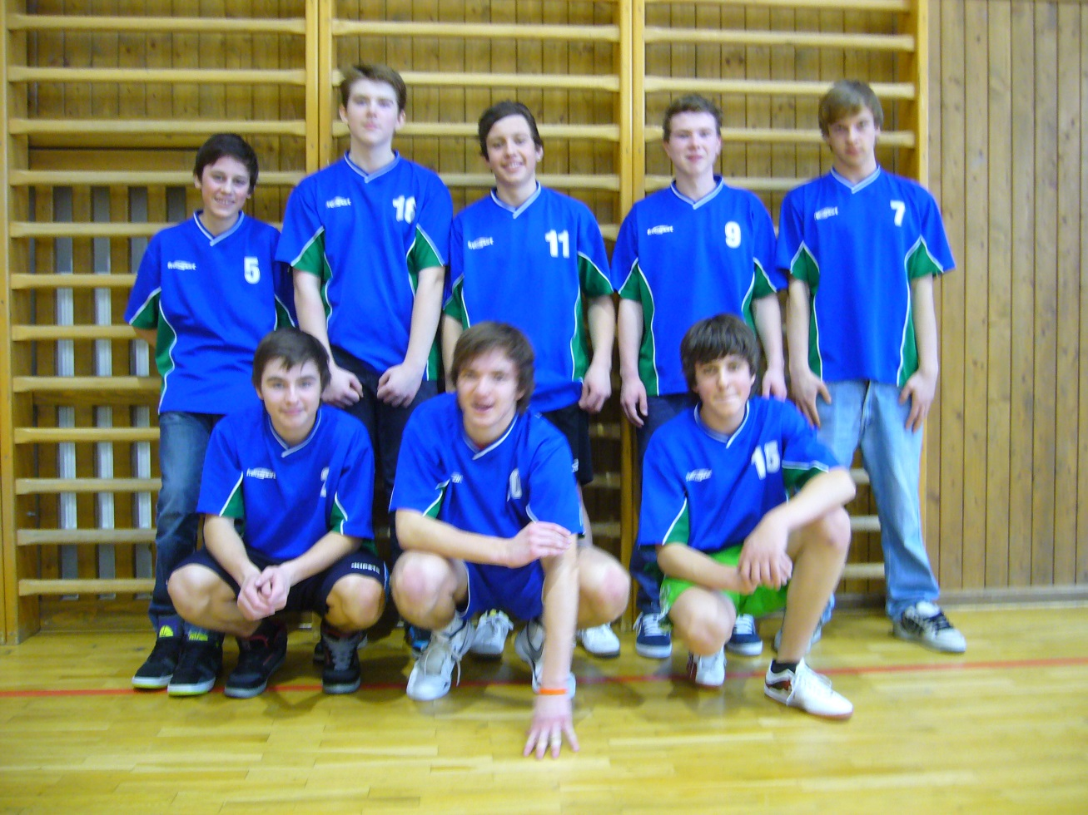

Volejbal okrsek 2013 dívky

|  |  |  |  |  |  |  |
| --- | --- | --- | --- | --- | --- | --- |
| C:\Users\skola\AppData\Local\Microsoft\Windows\Temporary Internet Files\Content.IE5\KL8A44QK\MC900398269[1].wmf | Karolinka | Nový Hrozenkov | Hovězí | body | skóre | pořadí |
| Karolinka | C:\Users\skola\AppData\Local\Microsoft\Windows\Temporary Internet Files\Content.IE5\KL8A44QK\MC900398269[1].wmf | 0:2  (15:25,21:25) | 0:2  (8:25,21:25) | 0 | 65:100 | 3. |
| Nový Hrozenkov | 2:0  (25:15,25:21) | C:\Users\skola\AppData\Local\Microsoft\Windows\Temporary Internet Files\Content.IE5\KL8A44QK\MC900398269[1].wmf | 1:1  (25:23,15:25) | 3 | 90:84 | 2. |
| Hovězí | 2:0  (25:8,25:21) | 1:1  (23:25,25:15) | C:\Users\skola\AppData\Local\Microsoft\Windows\Temporary Internet Files\Content.IE5\KL8A44QK\MC900398269[1].wmf | 3 | 98:69 | 1. |

